**Page Object Model(POM)**

Example 1: Google search example

Googlesearchclass:

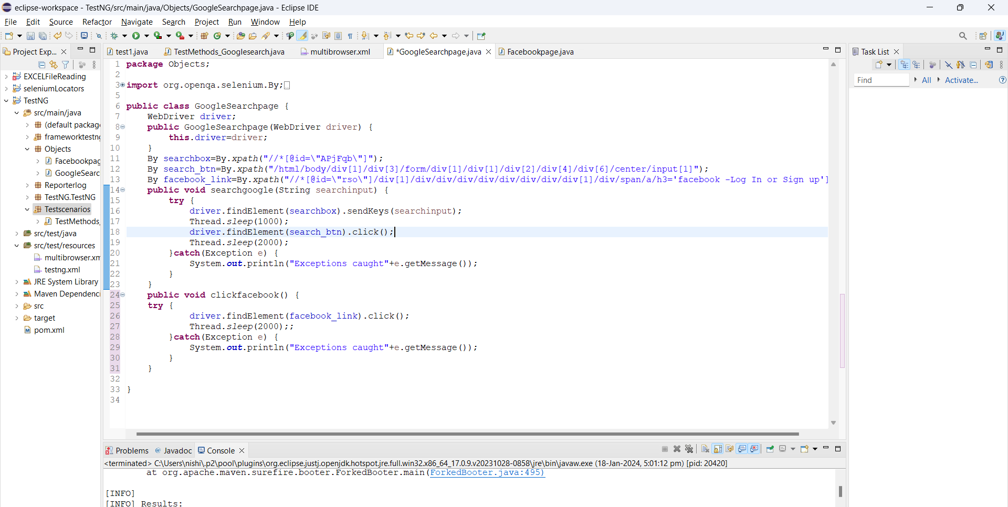

Facebookloginclass:

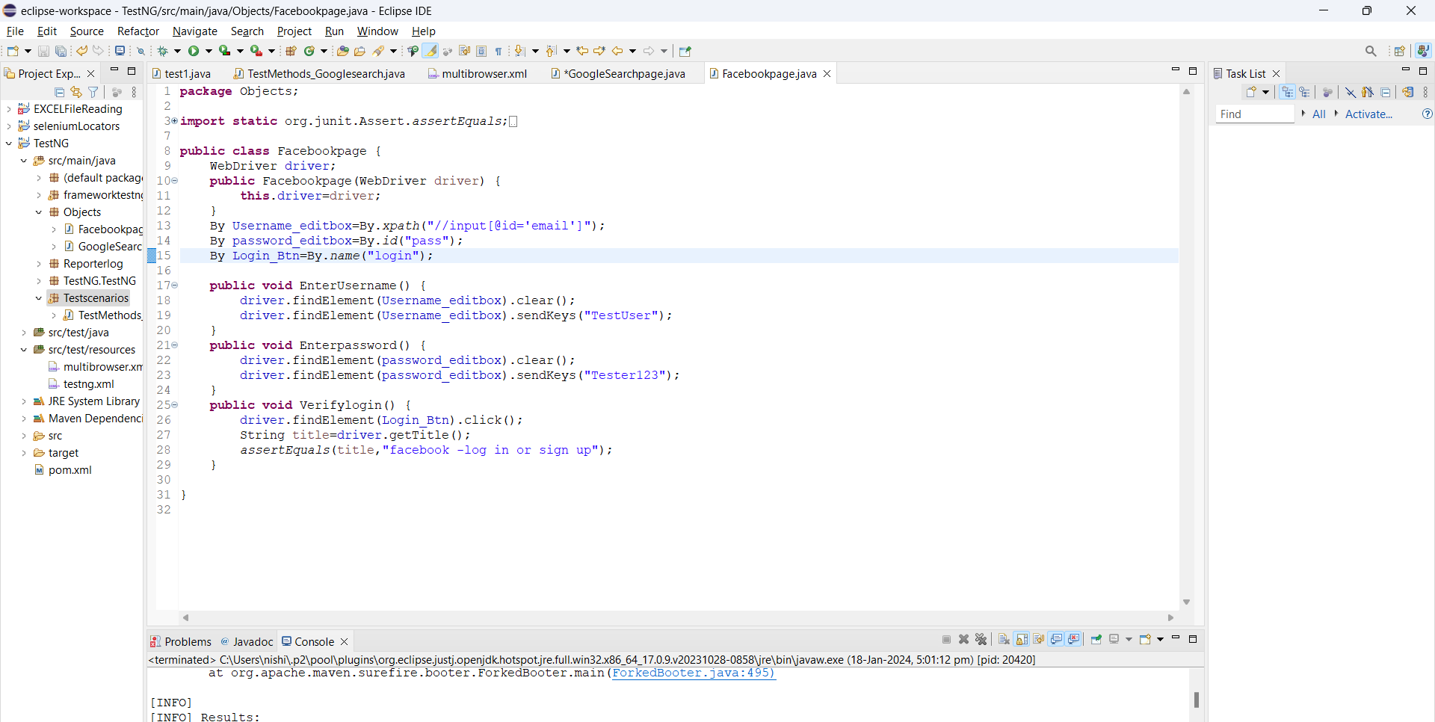

TestMethods_Googlesearch:

